ASSIGNMENT – 47

Aggregate functions

1.average

select avg(salary)

from employees;

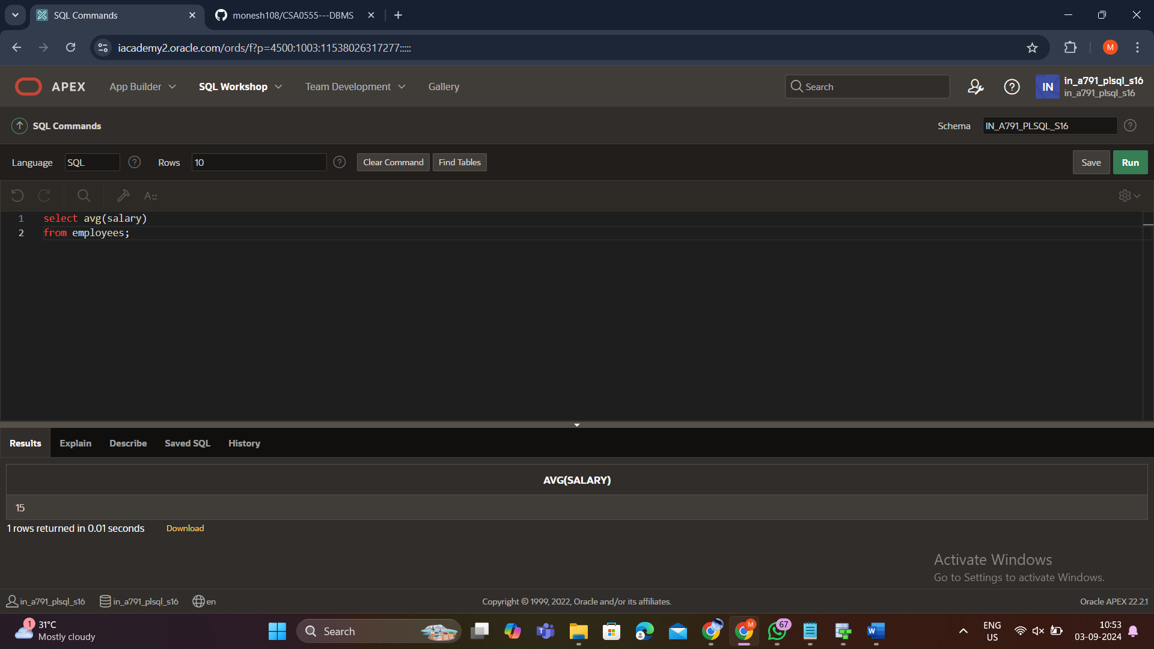

2. Summation:

select sum(salary)

from employees;

3. Max:

select max(salary)

from employees;

4. Min:

select min(salary)

from employees;

